
VETRIPATH
ABSTRACT
VetriPath is an offline-first hybrid educational portal and native Android mobile application engineered for candidates preparing for campus placements, technical interviews, and competitive exams. Built using a decoupled WebView architecture wrapped inside an Android Jetpack Compose native shell, VetriPath delivers zero-latency access to over 2,000 randomized quantitative, reasoning, verbal, and coding practice problems.
SYSTEM ANALYSIS
Feasibility Study
Technical Feasibility: Built on stable web execution engines (HTML5/CSS3/ES6 JS) and Android Native WebView interop APIs. Operates 100% offline.
Economic Feasibility: Serverless client-side architecture with zero hosting fees ($0 operational overhead).
Operational Feasibility: Features an intuitive glassmorphic UI layout requiring zero user training.
Existing System & Drawbacks
Current portals require continuous internet, suffer from ad latency, and lack anti-cheating mechanisms during exams.
Proposed System & Benefits
100% offline access, sub-50ms navigation, Jetpack Compose Biometric Shield, and client-side tab blur auto-submission.
Scope of the Project
Comprehensive preparation platform covering 30+ aptitude topics, coding workstation, timed mock tests, and roadmaps.
SYSTEM SPECIFICATION
Hardware Configuration
Development Unit: Intel Core i5 / AMD Ryzen 5, 8 GB RAM, 10 GB Disk Space.
Target Mobile: Android Smartphone running Android 8.0+ with biometric sensor.
Software Configuration
Tech Stack: Android 8.0+, Kotlin 1.9, Java, JavaScript ES6+, HTML5, CSS3, Jetpack Compose, WebView.
SYSTEM DESIGN
Software Modules
VetriPath comprises 12 core software modules covering Dashboard, Aptitude, Reasoning, Verbal, Coding Workstation, Practice Hub, Mock Test Simulator, Bookmarks, Roadmap, Global Search, About, and Contact.
Dataflow Diagram (DFD)
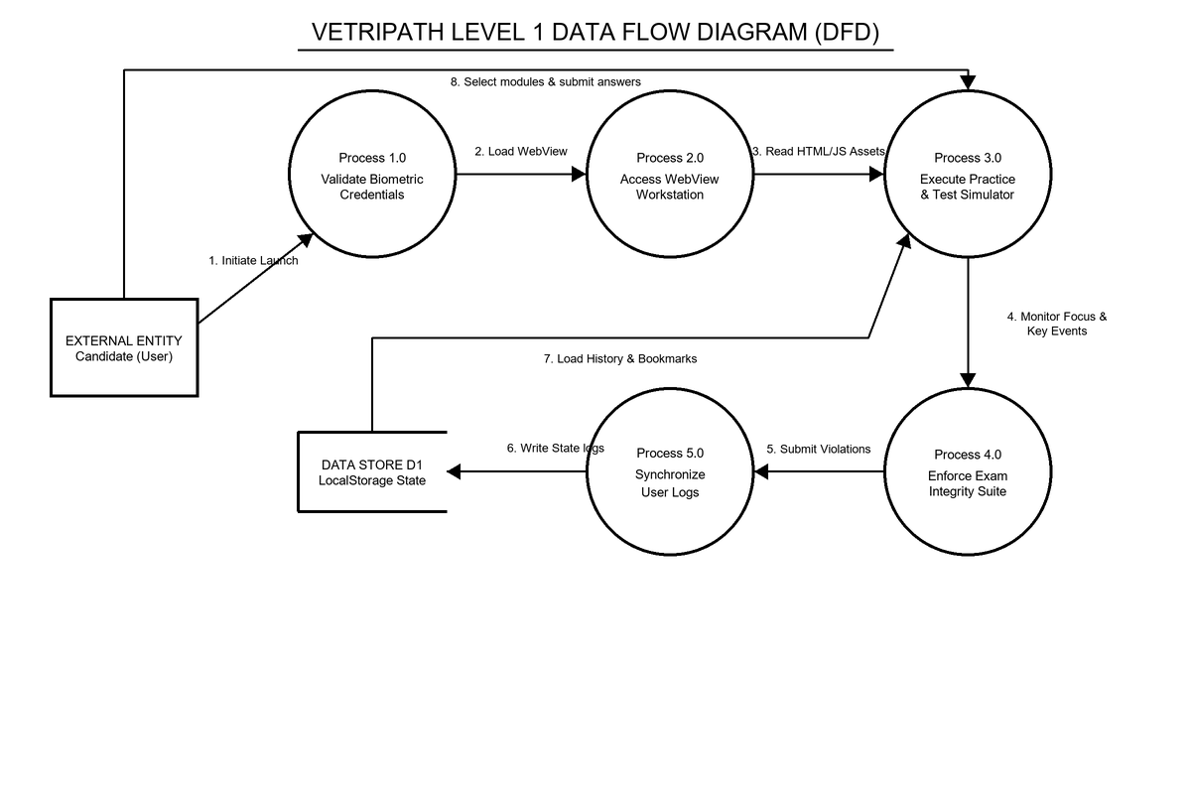
Architecture Diagram
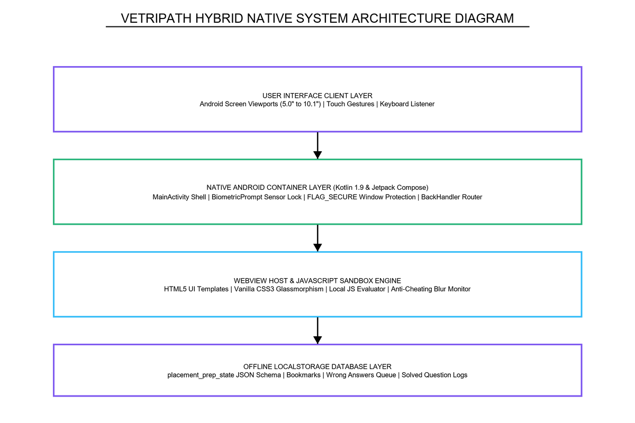
Database Design
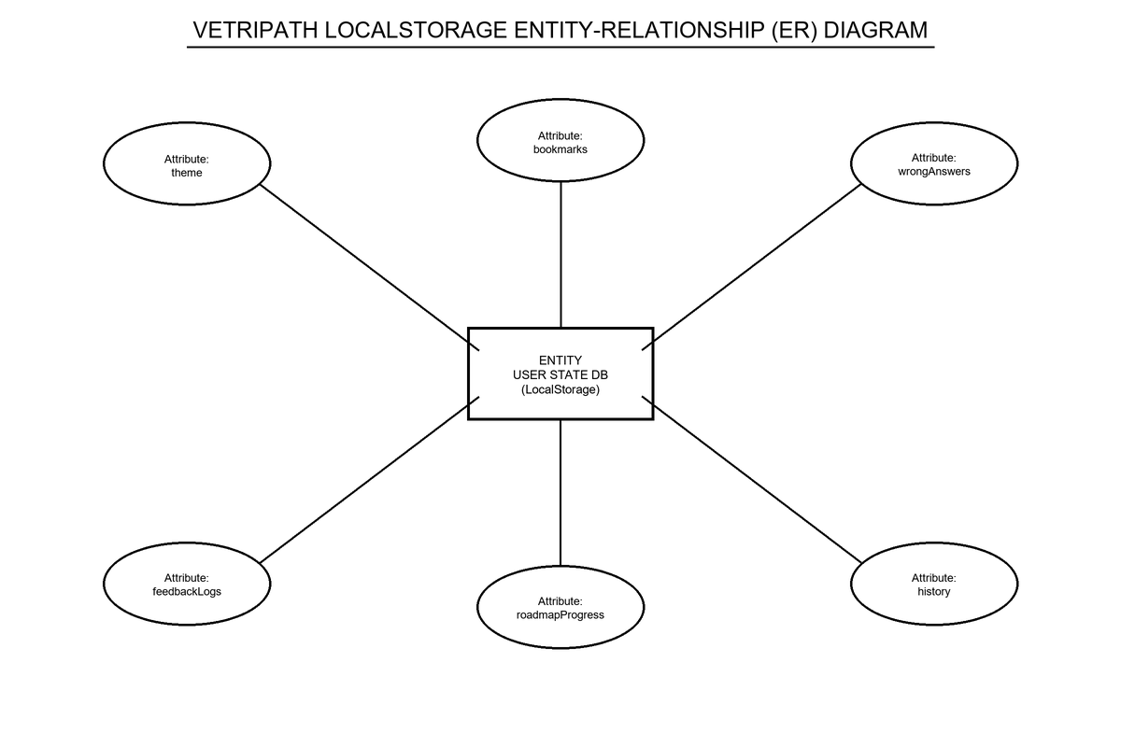
SYSTEM IMPLEMENTATION
Coding & Screenshots
Figure: Screen Capture: Dashboard UI
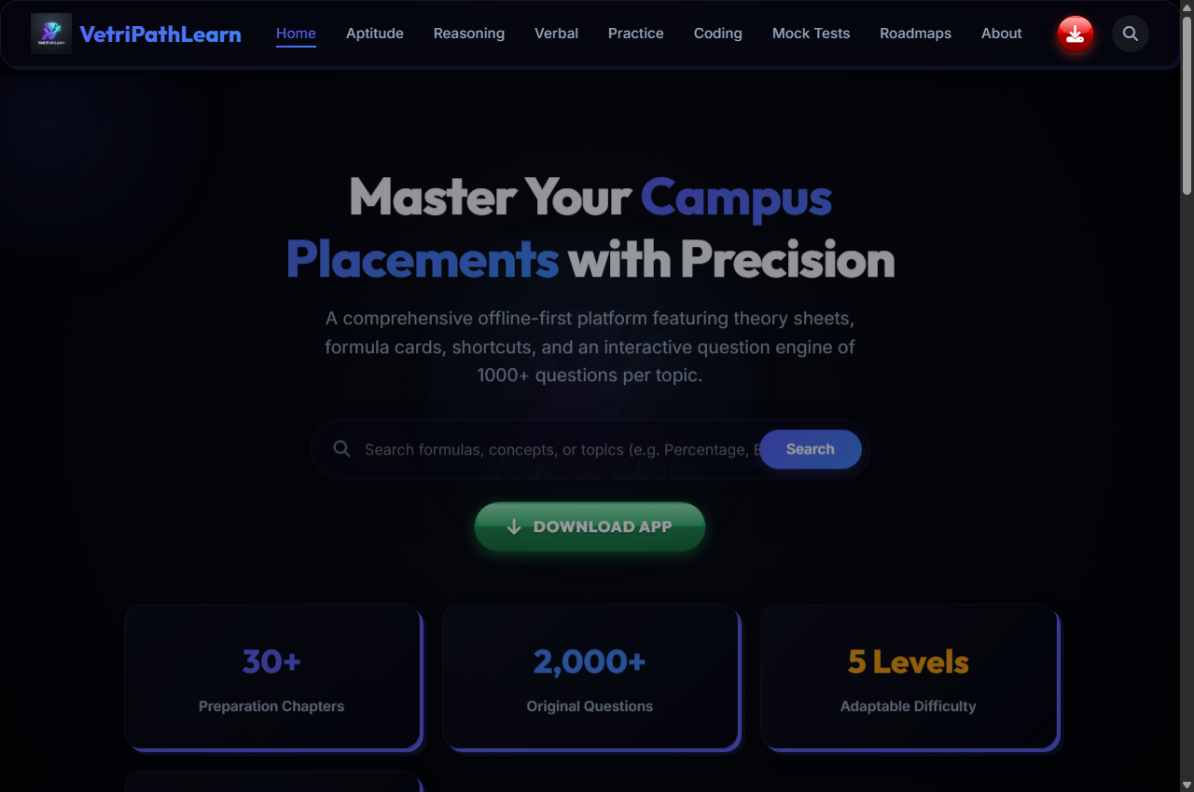
Figure: Screen Capture: Aptitude UI
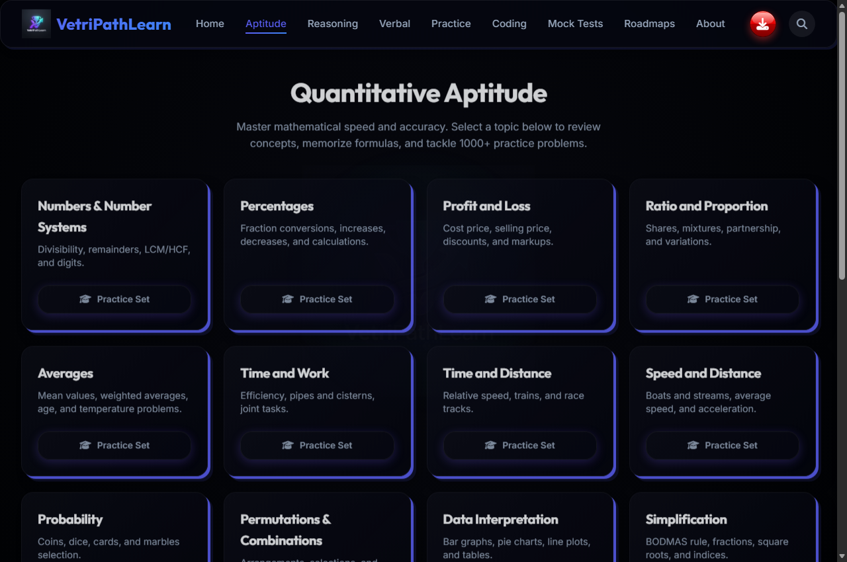
Figure: Screen Capture: Reasoning UI
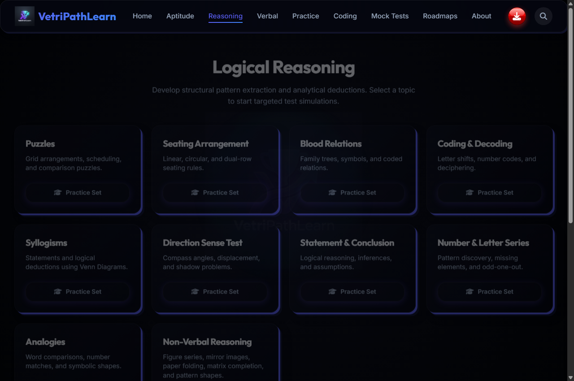
Figure: Screen Capture: Verbal UI
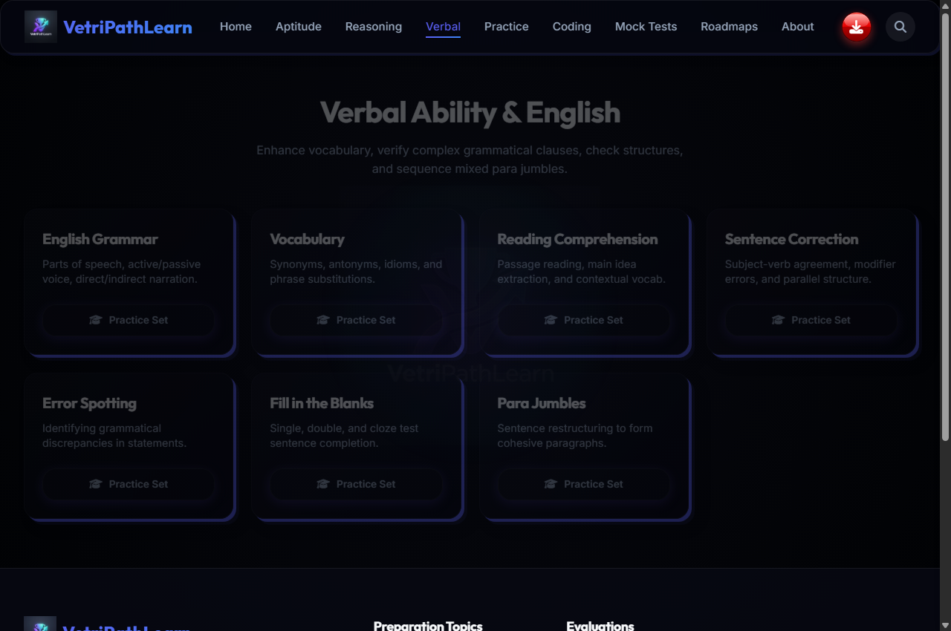
Figure: Screen Capture: Coding Workstation UI
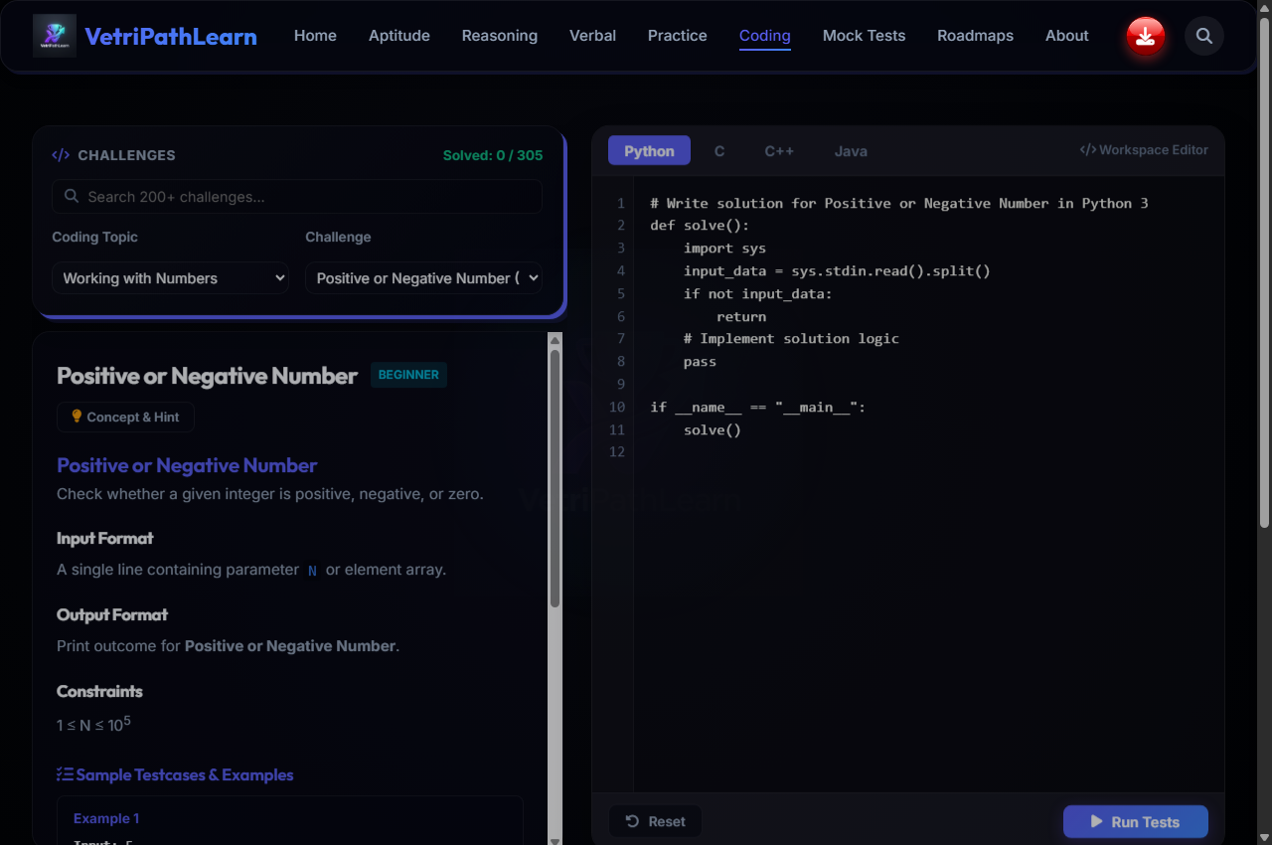
Figure: Screen Capture: Mock Test Simulator UI
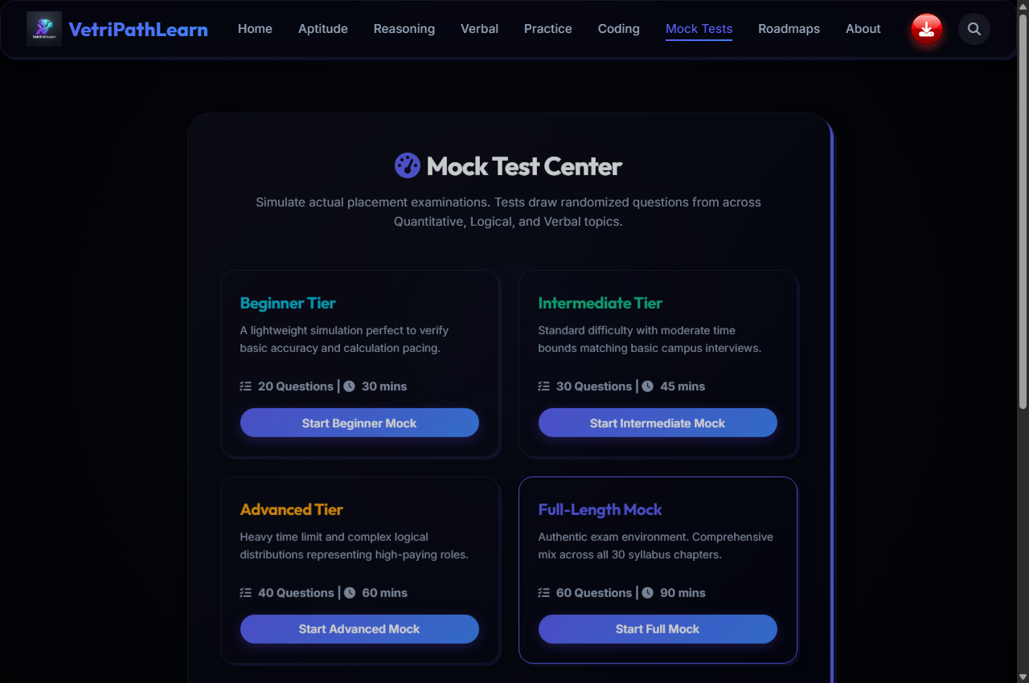
Figure: Screen Capture: Aptitude Active Quiz Sample
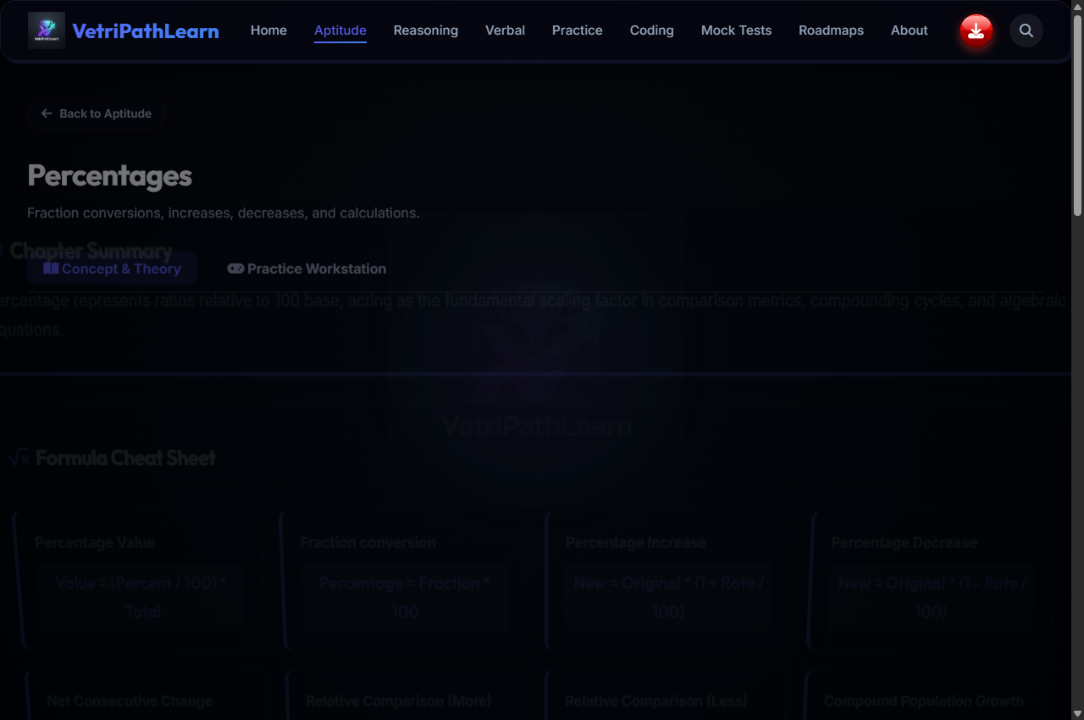
Figure: Screen Capture: Reasoning Active Quiz Sample
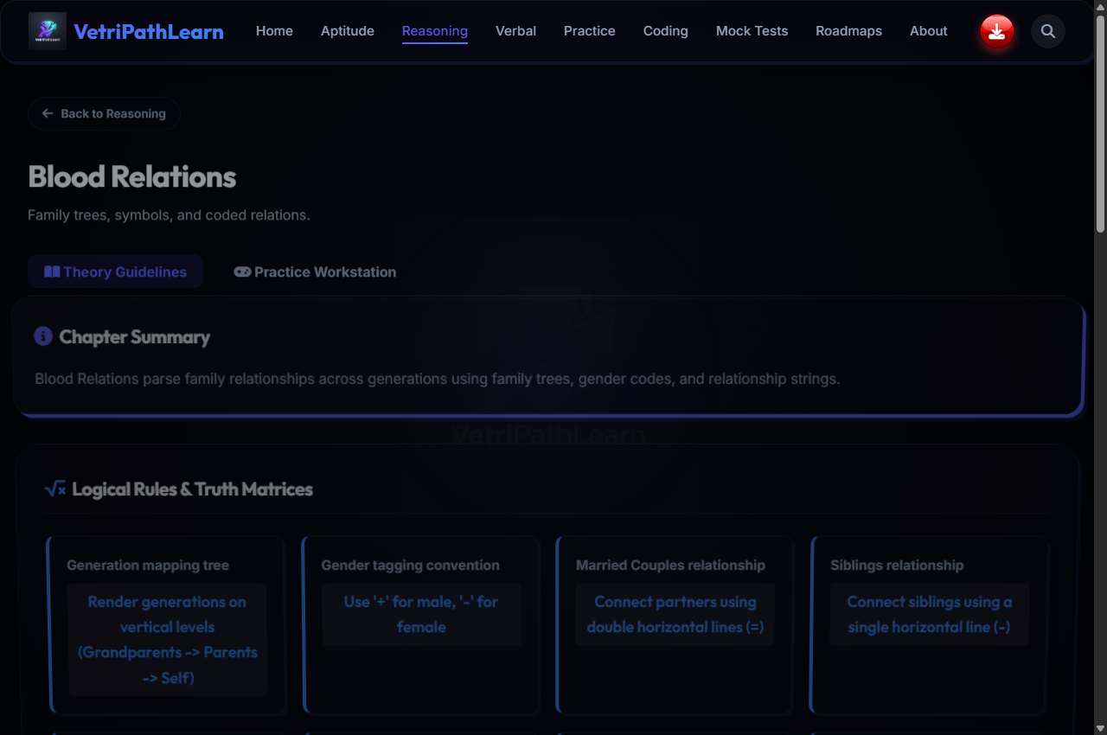
Figure: Screen Capture: Verbal Active Quiz Sample
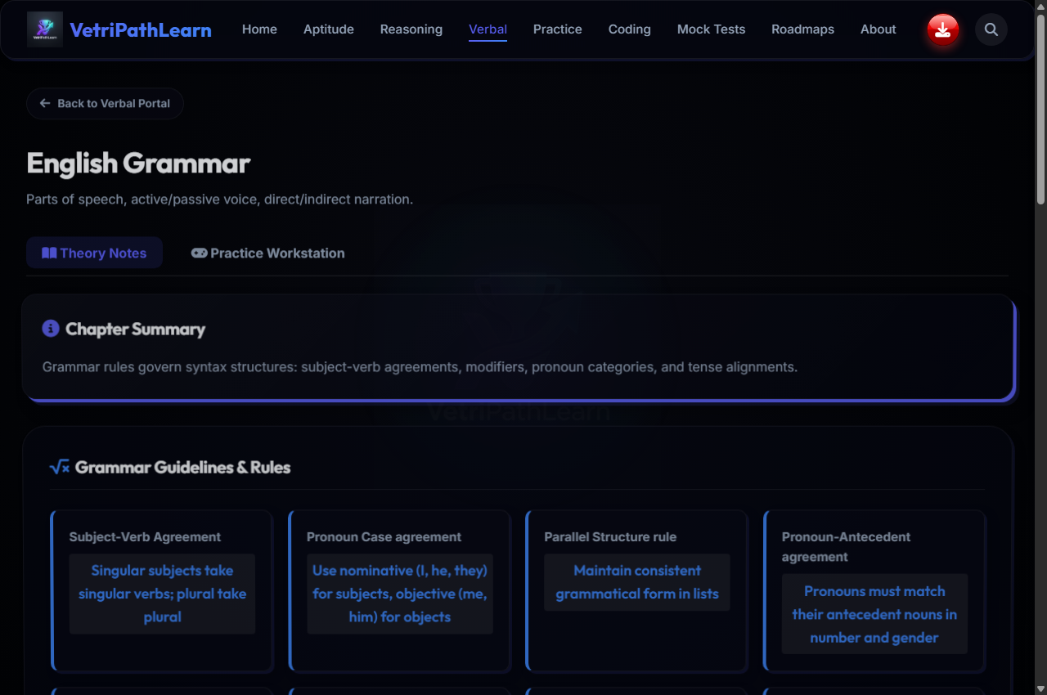
Figure: Screen Capture: Coding Workstation Sample
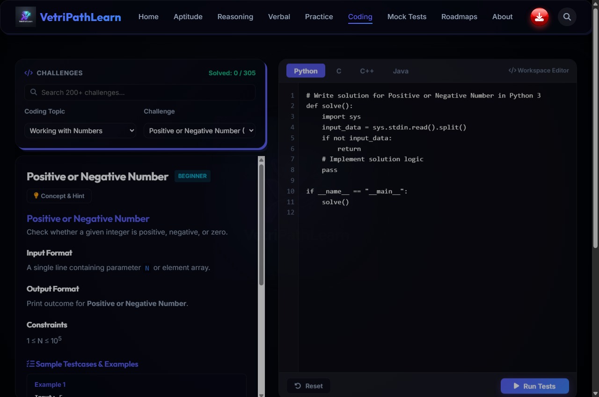
Figure: Screen Capture: Timed Exam Simulator Sample
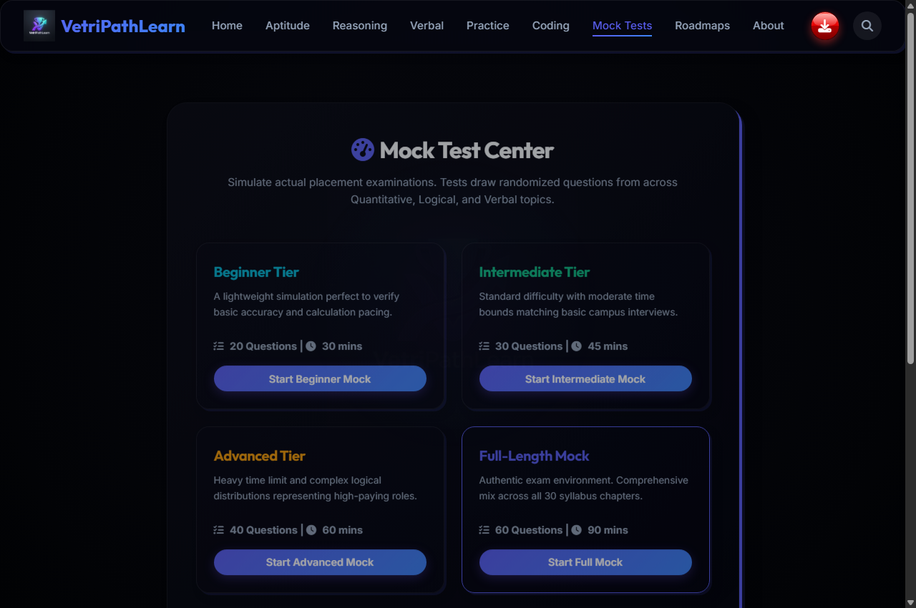
System Testing & Future Enhancements
Comprehensive unit, integration, anti-cheating, and responsive test cases executed with 100% PASS rate.
Future enhancements include cloud sync middleware, AI diagnostics, WebSockets competition, and instructor portal.

